Chapter 7 Stat Crunch Guide

Single Sample t-test WITH DATA

Enter the data (or copy and paste from the homework question).

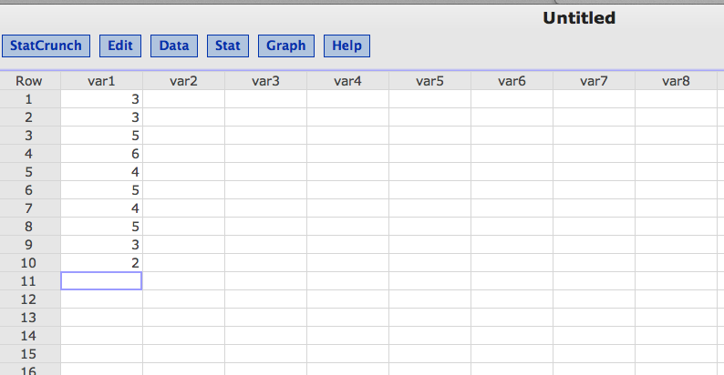

Click Stat > T Statistics > One Sample > with Data

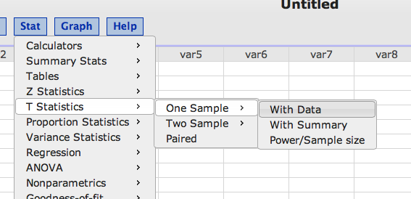

Click on your variable so it moves to the right.

Be sure to change the population mean (um).

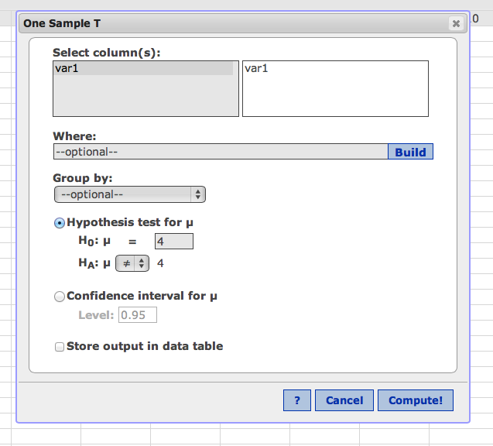

Hit compute!

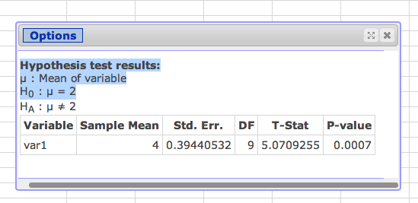

Step 2

Sample mean = M

Std. Err. = Sm

DF = Degrees of freedom (N-1)

Step 4

T-stat

To get confidence intervals click options > edit, which will take you back to the main window.

Click confidence interval for u.

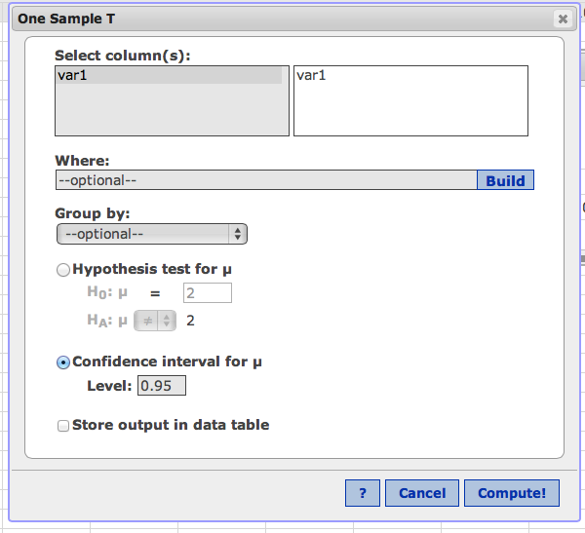

Change to .99 if p<.01.

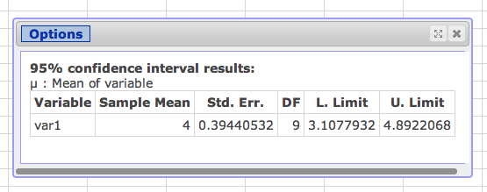

Effect size and SS

How to get effect size:

d = (mean – um) / SD

So you need SD.

Click Stat > Summary Stat > Columns

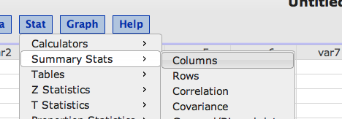

Pick your data (var 1 in my example), click on it to move it to the right.

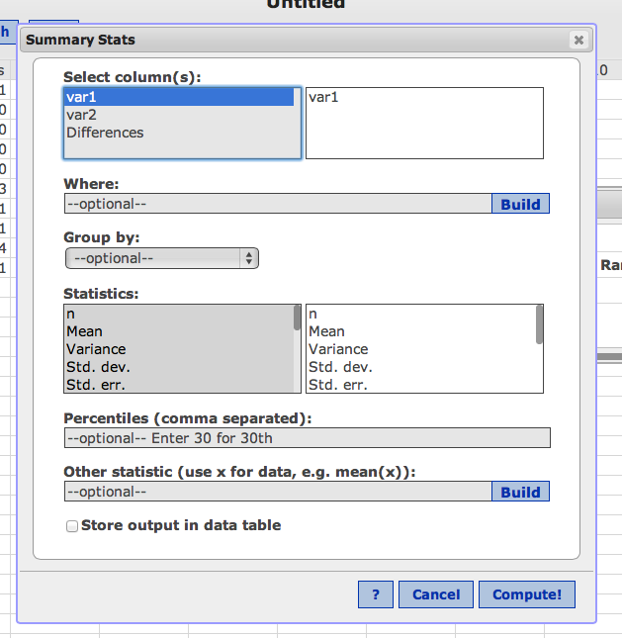

Hit compute.

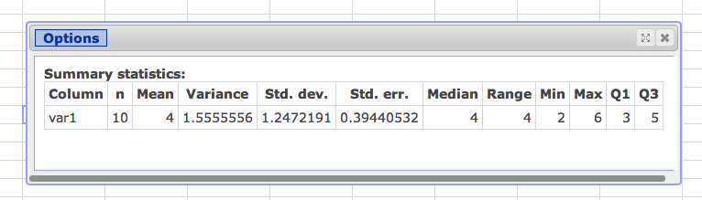

Mean = M

Variance = SD squared.

Std. Dev. = SD.

Std. err. = Sm

DF = N – 1

To get SS for questions:

SS = variance \* df

Single Sample t-test WITH SUMMARY

In this example, you will not have the raw numbers, just the averages.

M = 2

SD = 1.5

Um = 4

N = 10

Click > Stat > T Statistics > One Sample > With Summary

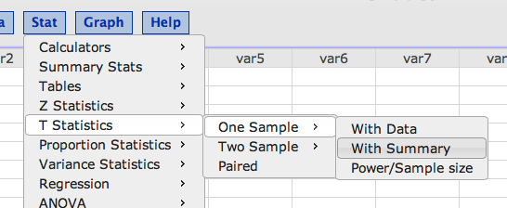

Enter all the numbers (don’t forget um!)

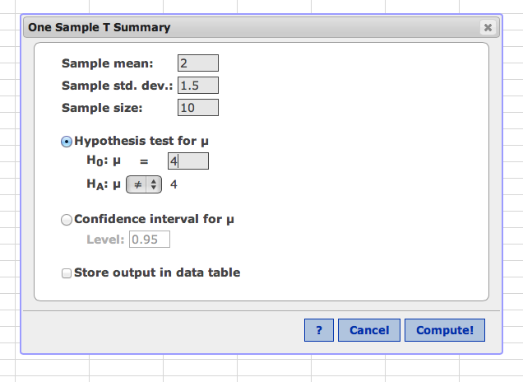

Hit compute.

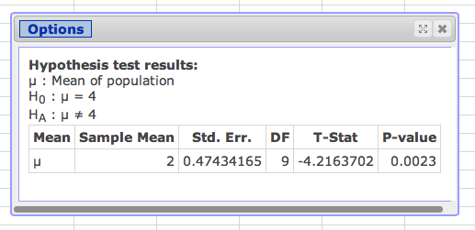

Step 2

Sample mean = M

Std. Err. = Sm

DF = Degrees of freedom (N-1)

Step 4

T-stat

To get confidence intervals click options > edit, which will take you back to the main window.

Click confidence interval for u. Remember to change it to .99 for p<.01. (See pictures above).

Dependent t-test (paired t-test)

In this example, you have people who have been tested twice. Remember to put their scores next to each other in the data entry.

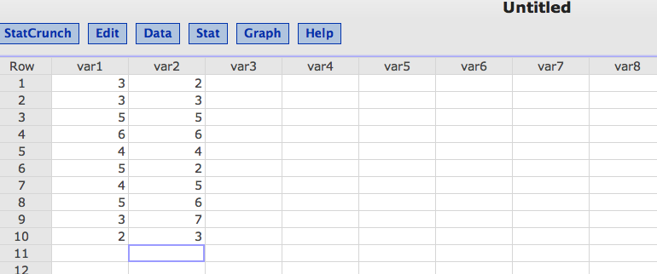

Click Stat > T Statistics > Paired.

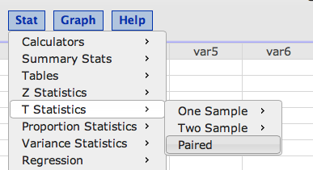

Put in sample 1 and sample 2 as time 1 and time 2. Click save differences. Leave u = 0 (because we do not expect a change from time 1 to time 2).

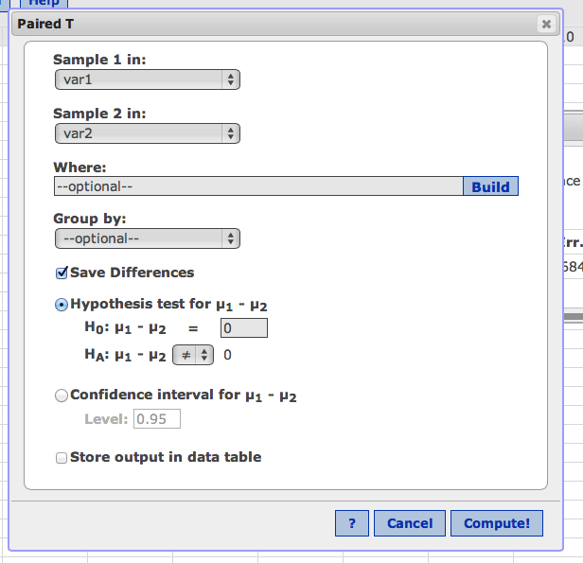

Hit compute!

You’ll get a new column called Differences.

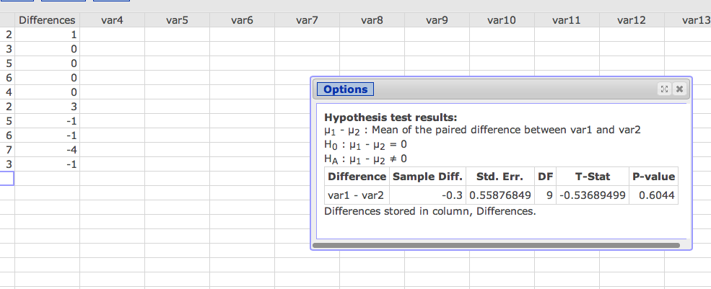

Step 2

Sample Diff = Mdifference

Std. Err. = Sm difference

DF = N – 1

Step 4

T-stat

To get confidence intervals click options > edit, which will take you back to the main window.

Click confidence interval for u. Remember to change it to .99 for p<.01. (See pictures above).

Why differences?

EFFECT SIZE:

Remember effect size = mean difference / sd differences

SD difference = Sm difference \* sqrt N

OR

Use the difference column just created to calculate sd difference.

Click Stat > Summary Stat > Columns

Click on the difference variable. Hit compute (you can take out some of the numbers it’s calculating if it confuses you).

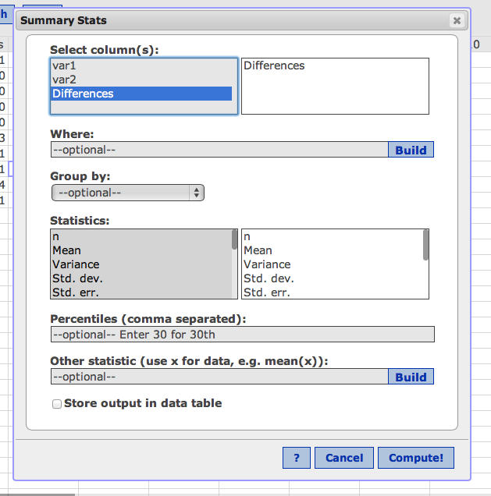

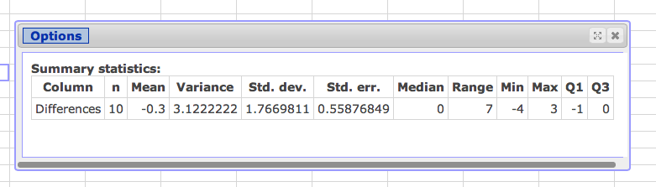

M = mean difference

Variance = SD differences squared

Std. dev. = SD differences

Std. err. = Sm differences

d = M / std. dev.

SS differences = variance \* df